Experiment worksheet

4.2 Renewable resources can be quickly replaced

Pages 64–65 and 186-187

Challenge 4.2: Can you increase the output of a power station

Design brief

Modify the design of a model power station so that you increase the rate at which the turbine spins.

Criteria restrictions



**Figure 1**

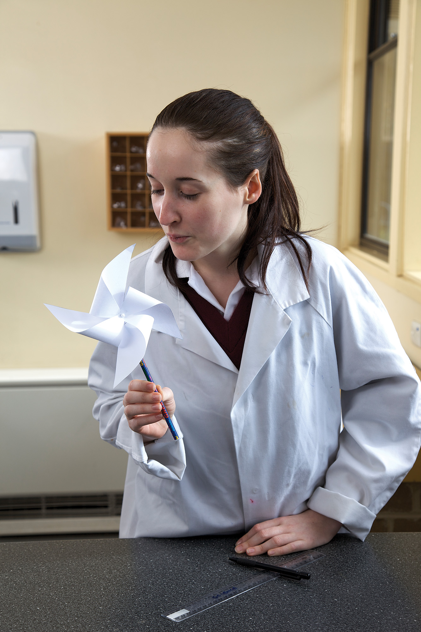

**Figure 2**

Only the following materials can be used:

• Square paper (15 cm × 15 cm) cut from one A4 sheet

• Ruler

• Pencil with eraser on the end

• Scissors

• Pin

• Electric kettle

• Bunsen burner

• Tripod

• Gauze mat

• 150 mL beaker

• Aluminium foil (1 piece, 10 cm × 10 cm)

• Large nail

Questioning and predicting

• How could you improve the turbine?

• How could you increase the production of steam?

• How could you ensure the quantity and speed of the steam that hits the turbine?

Planning and conducting

THE TURBINE

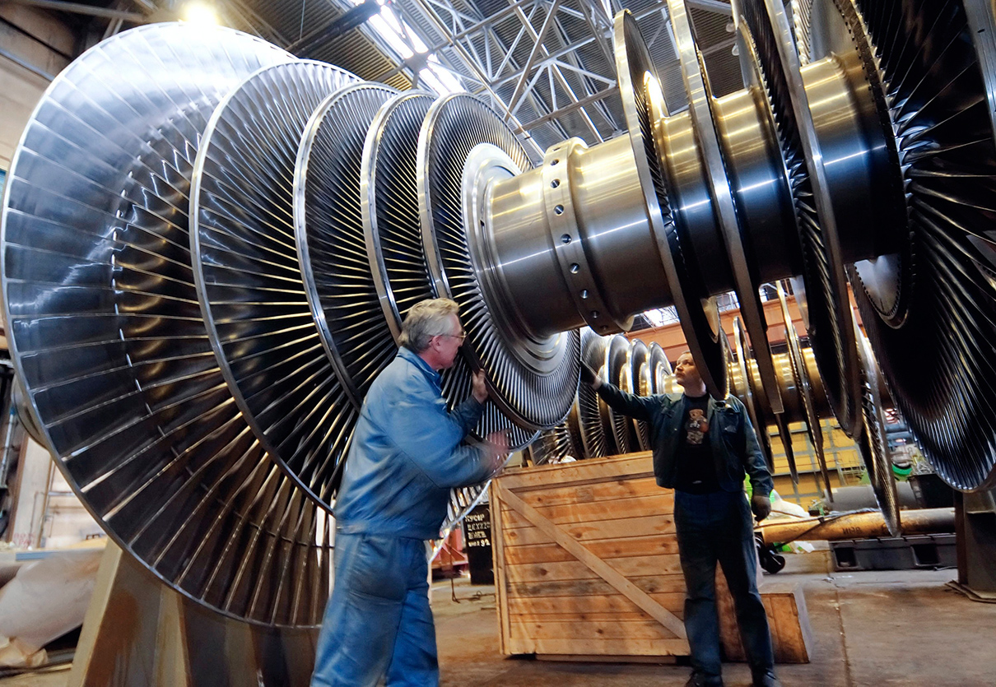

**Figure 3** A turbine assembly in a power station

1 Mark the square paper as shown in Figure 1 using a pencil and a ruler. Draw a circle in the centre about the size of a 5-cent piece.

2 Cut along the lines, but stop at the edges of the circle.

3 Fold all four corners in towards the centre, one at a time, and hold them in place.

4 Insert a pin through the four corners and into the tip of the pencil’s eraser.

5 Blow on the pinwheel to see if it spins (Figure 2). If not, pull the pin out slightly to create room for the paper to spin. The pinwheel will act like the turbine of the power station.

THE BOILER

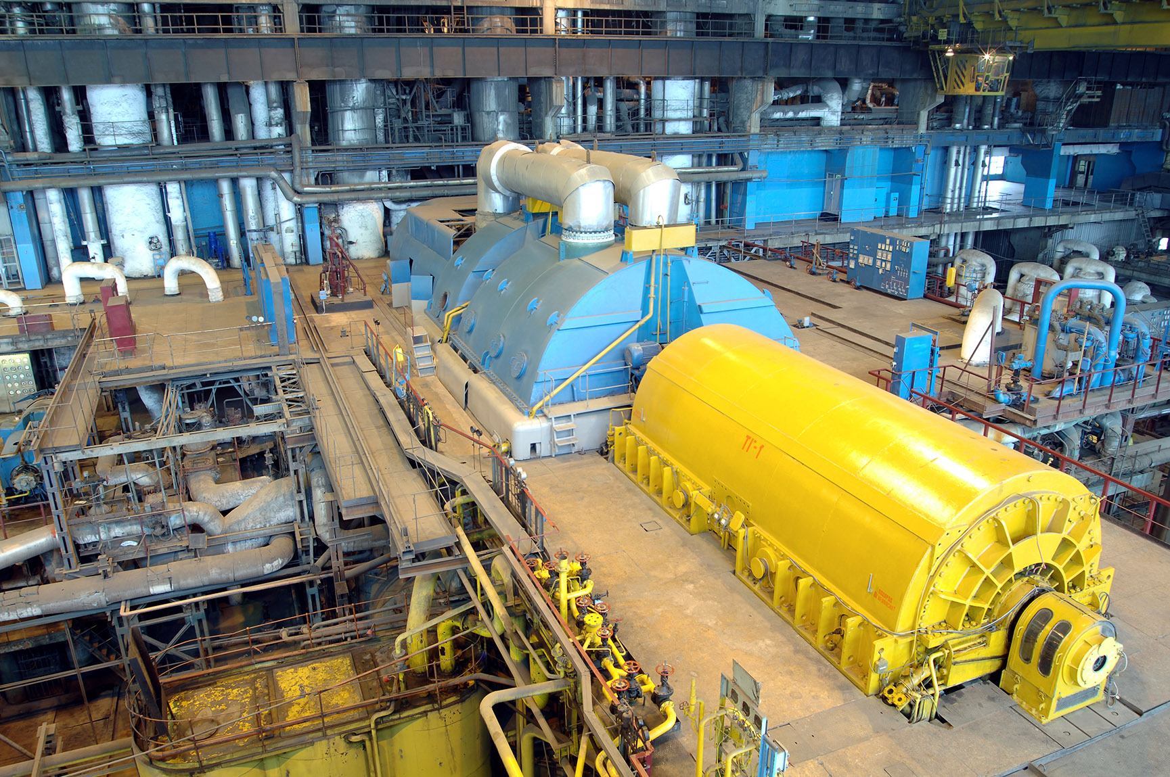

**Figure 4** A generator in a power station

1 Set up your Bunsen burner, tripod and gauze mat. Place the beaker on top of the gauze mat.

2 Boil the kettle and transfer the boiling water to the beaker.

**CAUTION:** HANDLE THE KETTLE CAREFULLY TO AVOID BURNS AND SCOLDS.

3 Use the nail to punch a small hole in the centre of the aluminium foil.

4 Place the aluminium foil over the top of the beaker and fold it down the sides of the beaker.

**CAUTION:** THE BOILING WATER IN THE BEAKER WILL HAVE MADE THE SIDES OF THE BEAKER HOT. BE CAREFUL TO AVOID BURNS WHEN PLACING THE FOIL.

5 Light your Bunsen burner and heat the water until it boils again.

6 Steam should be coming out of the hole. Hold your pinwheel over the hole and let the steam spin the ‘turbine’.

Processing, analysing and evaluating

1 Describe what happened to your pinwheel when it was placed in the steam flow.

2 What else would you need to add to make your ‘powerstation’ generate electricity?

3 What is the fuel in your power station?

4 Will your power station run out of fuel?

Communicating

What do you know about the action of a power station?

Experiment worksheet

4.3 Renewable resources can be harnessed to provide energy

Pages 66–67 and 188

Challenge 4.3: Can you increase the power of solar cells?

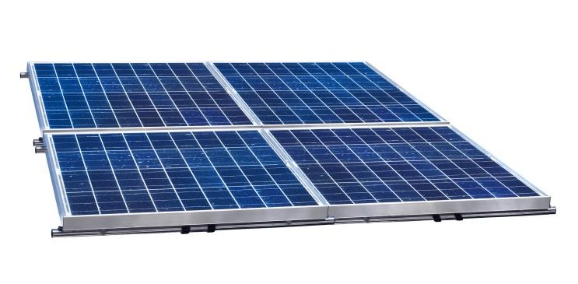Design brief

Modify the design of the solar cell so that it produces the highest voltage.

Materials

• Small solar cells

• Electrical wires

• Voltmeter

Questioning and predicting

1 How could you maximise the amount of sunlight the solar cell receives?

2 Does cleaning the solar cell improve the voltage produced?

3 How could you connect more than one solar cell so that the amount of voltage produced increases?

Planning and conducting

1 While inside, connect a solar cell to the voltmeter using the electrical wires.

2 While still inside, record the voltmeter reading.

3 Cover the solar cell with your hand and record the voltmeter reading.

4 Take the solar cell over to a window and record the voltmeter reading.

5 Take the solar cell outside, face it towards the sun and record the voltmeter reading. If it is cloudy outside, take a reading and then repeat the measurement when the clouds clear or on another day when it is sunny.

6 Cover the solar cell with a thin layer of dust and repeat the measurement. Clean the solar panels carefully.

7 Connect solar cells together in series (i.e. in a line) and record the voltmeter reading.

Processing, analysing and evaluating

Record your results in the table below.

|  |  |  |
| --- | --- | --- |
| Location | Number of solar cells | Voltmeter reading |
| Inside |  |  |
| Inside, covered |  |  |
| Window |  |  |
| Outside, sunny |  |  |
| Outside, cloudy |  |  |
| Outside, dusty |  |  |
| Outside, multiple cells |  |  |

1 What are the best conditions for generating electricity from a solar cell?

2 Why do you think a house with a solar energy installation will have six, eight or more solar cells on its roof?

3 Why should solar panels on a house roof be cleaned regularly?

Communicating

1 What do you know about the amount of electricity produced by solar cells?

Experiment worksheet

4.4 Non-renewable resources are limited

Pages 68–69 and 189

Experiment 4.4A: What if a muffin were mined in different ways?

Aim

To compare the effectiveness of different methods of mining and their impact on the environment.

Materials

• 2 homemade chocolate chip muffins (each with the same number of chocolate chips – approximately 20)

• Plastic plates

• Spoons

Method

1 Imagine each muffin is an area of land that contains a valuable ore: chocolate.

2 Use spoons to ‘mine’ the chocolate from the first muffin using the ‘open cut’ method, taking layers off the top and collecting the chocolate as it appears.

Inquiry: What if the muffin was mined using the underground method?

1 How will you mine this muffin so that the top remains intact?

2 What (dependent) variable will you measure and/or observe to determine which method was more effective?

3 Is the way you determine which method was more effective different from the way you will compare the impact of the two methods on the muffin top?

4 Name three variables you will keep the same or control.

Results

Draw or take a picture of your two muffins.

|  |
| --- |
|  |

Discussion

1 Which method recovered the most ore?

2 Which method was faster?

3 Which method was easier?

4 Which method would allow the environment to be rehabilitated more easily?

Experiment worksheet

4.4 Non-renewable resources are limited

Pages 68–69 and 190

Experiment 4.4B: What if a metal were obtained from a mineral?

Aim

To obtain pure copper from the mineral copper sulfate.

Materials

• Power supply

• 2 electrical leads with alligator clips on one end

• 2 carbon rods

• 250 mL beaker

• 0.5 M copper sulfate solution

• Safety glasses

• Paper towel

Method

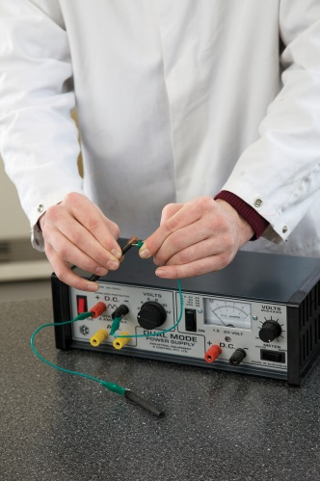 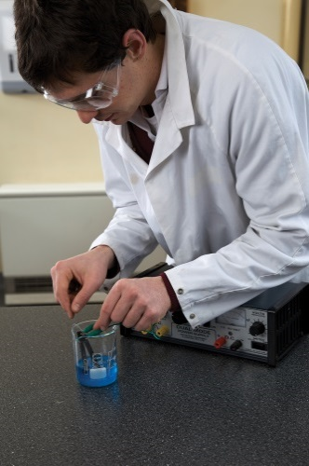 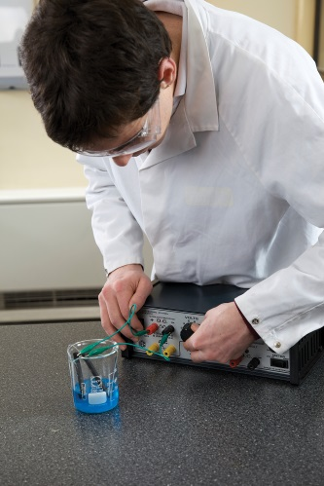

1 Plug the electrical leads into the DC terminals of the power supply.

2 Connect the top end of the carbon rods to the alligator clips on the end of the electrical leads.

3 Fill the beaker with approximately 100 mL of the copper sulfate solution.

4 Place the carbon rods into the copper sulfate solution, being careful not to let them touch each other or the beaker.

5 Set the power supply knob to 6 volts and turn the power on.

6 Observe the rods over the next 10 minutes.

7 After 10 minutes, turn the power supply off. Remove the carbon rods and place them on paper towel.

Inquiry: Improving metal production

Choose one of the inquiry questions below.

• What if the voltage was increased?

• What if more copper sulfate was used?

Answer the following questions with regard to your inquiry question.

1 Write a hypothesis for your inquiry.

2 What (independent) variable will you change from the first method?

3 What (dependent) variable will you measure and/or observe?

4 Name three variables you will keep the same or control.

5 What variables will you need to control to ensure a fair test? How will you control them?

Results

Record your observations about the appearance of the rods and the copper sulfate solution.

|  |
| --- |
|  |

Discussion

1 Examine something else made of copper, such as an old 1 or 2 cent coin or a copper water pipe. Does the coating on the rods look like pure copper?

2 Where did the copper coating come from?

3 What do you think the electricity did in this experiment?

Conclusion

How successful were you in obtaining pure copper from copper sulfate?

Experiment worksheet

4.5 Soil is one of our most valuable resources

Pages 70–71 and 191

Experiment 4.5: What if different soils were exposed to water?

Aim

To compare the components of different soils

A Looking at dry soil

Materials

• 4 soil samples (beach sand, dry clay, good garden soil, potting mix)

• 4 petri dishes

• 4 white tiles

• Hand lens (or magnifier)

Method

1 Grind each sample with a mortar and pestle and then spread each thinly on a Petri dish on top of a white tile.

2 Examine each sample with a hand lens and describe what you can see.

3 Draw a labelled diagram of each soil type in the space provided.

|  |  |  |  |
| --- | --- | --- | --- |
|  |  |  |  |

• Do all the particles have the same colour?

• Are they the same size?

• Are they clear and glossy or dull and grey?

• Are any of the particles rounded?

• Are there any animal or plant remains?

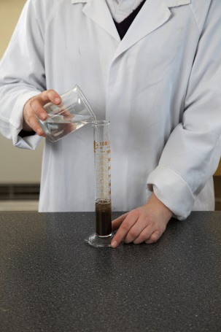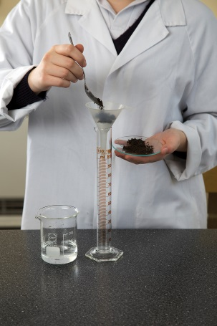B What’s in soil?

Materials

• Small sample of good garden soil

• 100 mL measuring cylinder

Method

1 Place the soil in the measuring cylinder and add water (refer to the images at right).

2 Carefully shake the mixture.

3 Allow the mixture to stand undisturbed for at least 48 hours, or longer if needed. This will allow the components of the soil to separate into layers.

• Did your soil separate into layers?

• Describe each layer.

• Did any of your soil components float?

C Testing

After examining the dry soil (part A) and what is in the soil (part B), predict which sample the water will flow through fastest in part C.

Materials

• 4 × 100 mL measuring cylinders

• 4 filter funnels

• 4 cotton balls

• 4 soil samples (beach sand, dry clay, good garden soil, potting mix)

• Stopwatch

Method

1 Press a cotton ball firmly into the V of each filter funnel.

2 Add 3 teaspoons of each soil sample to different funnels and press down firmly.

3 Place a funnel in the top of the measuring cylinder and add 20 mL of water.

4 Record the time it takes for the water to flow into the funnel.

5 Repeat steps 3 and 4 for the remaining three samples.

• What is the independent variable in your experiment?

• What is the dependent variable in your experiment?

• Name three variables you will need to control during this experiment.

Results

Record your observations and measurements in a table.

|  |
| --- |
|  |

Discussion

1 Which soil drained the fastest?

2 Which soil stopped the most water from flowing?

3 Which soil absorbed water best?

4 Why were the water-holding abilities different?

5 How accurate was your prediction? Explain why you think this was so.

6 What qualities does a good soil need to have for plants to grow well in it?

Conclusion

Compare the water-holding ability of the four soils.

Experiment worksheet

4.6 Our future depends on careful management of resources

Pages 72–73 and 192

Challenge 4.6: Resources for your future

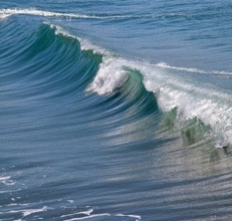 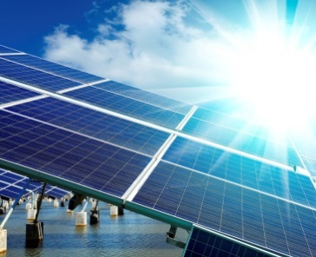 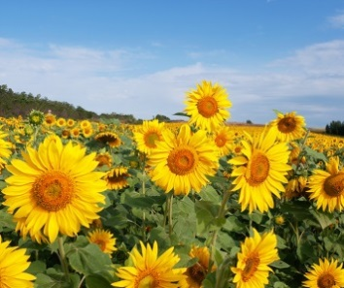 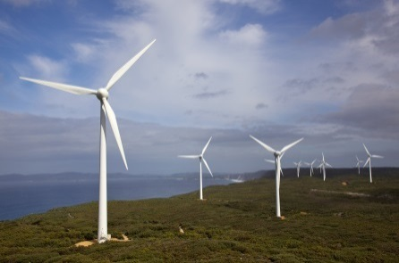

Working in a small group, research and prepare a report about the depletion (using up) of one of the world’s natural resources.

In your report, include:

• A brief summary of the topic

• What has caused the depletion of your chosen natural resource

• The effects of depletion of this natural resource

• Short- and long-term solutions to this problem

• The role of public education in solving this problem

• What you could do about this problem.

Present your report to the class as a speech and short multimedia presentation.